Retaliation and Harassment complaint

I am writing to formally complain about the retaliation I have been experiencing from my manager since raising concerns about policy violations and discrimination on September 6th, 2023. I believe this retaliation is in direct response to my protected activity, and I am requesting immediate investigation and action to address these issues.



Intentionally denying people a fair opportunity at work – whether it’s by undermining the success of a project or adversely impacting some other employment opportunity, such as hiring, a promotion, or a transfer.

Providing a negative performance review or reducing a performance rating solely because an employee takes protected action like raising a workplace complaint or reporting inappropriate workplace conduct.

Being intentionally excluded from workplace activities, including team social or networking opportunities, or meetings related to current assignments.

Malicious expressions of disapproval; e.g., ignoring emails, chats, or calendar invites.



## Timeline of Events: Complaints Raised

| Date | Department | Issue Raised |
| --- | --- | --- |
| Sept 6th, 2023 | Employee Relations | Reported policy violation and other discrimination |
| Sept 7th, 2023 | Manager | Informed manager about raising concerns with HR |
| Oct 2nd, 2023 | Workers Compensation | Filed claim for work-related medical issues including stress, anxiety disorder, PTSD, GERD, and other illnesses caused by manager's harassment |
| Oct 3rd, 2023 | Ethicspoint | Reported policy violations related to hiring irregularities and harassment based on my immigration status |
| Oct 27th, 2023 | People Ops - Accommodation Request | Submitted accommodation request for   1. manager change or 2. someone present during 1:1s due to PTSD |
| Oct 28th, 2023 | People Ops - GRAD | Concerns regarding review and promotion process |

## Summary of Retaliatory actions

| Date | Retaliatory Action | People aware of the situation |
| --- | --- | --- |
| September 14, 2023 (ongoing) | Increased Scrutiny and Creation of False Paper Trail Following Complaint | [Henry Chang](mailto:henryc@google.com) |
| September 15, 2023 | Manipulation of GRAD Peer Feedback for Retaliatory Purposes | [Henry Chang](mailto:henryc@google.com)  [Deepti Madala](mailto:deeptimadala@google.com)[Jebin Gnanadhas](mailto:merryjebin@google.com)[Manjunath Bidarkar](mailto:mbidarkar@google.com)[George Yang](mailto:geoyang@google.com) |
| September 28, 2023 and Nov 30, 2023 | Unfair write ups and Retaliatory Performance Evaluation Following Complaint | [Henry Chang](mailto:henryc@google.com) |
| October 26, 2023 | Unfair Denial of Promotion | [Henry Chang](mailto:henryc@google.com) |
| October 26, 2023 | Disregarding Mental Health Concerns During Meeting | [Henry Chang](mailto:henryc@google.com) |
| November 10, 2023 | Unjustified Exclusion from Crucial recurring meeting causing delay in my work deliverable | [Dustin Seberger](mailto:dustins@google.com), [Latha Koneru](mailto:lkoneru@google.com), [David Reis](mailto:davidareis@google.com), [Pankaj Sethi](mailto:sethipankaj@google.com) |
| November 14, 2023 | Reopening Closed Q2 OKR Item: Unjustified Claim of Incomplete Training | [Henry Chang](mailto:henryc@google.com) |
| November 15, 2023 | Public Humiliation and Retaliatory Defamation in Team Meeting | [Henry Chang](mailto:henryc@google.com)[Ameya Talwar](mailto:talwara@google.com)[Jebin Gnanadhas](mailto:merryjebin@google.com)[George Yang](mailto:geoyang@google.com)[Latha Koneru](mailto:lkoneru@google.com)[Ashley Shi](mailto:ashleyu@google.com) |
| November 16, 2023 | Creating Unnecessary Obstacles and Imposing Unrealistic Expectations: Hampering Work Progress and Well-being | [Henry Chang](mailto:henryc@google.com)[Chad Coughlin](mailto:cchad@google.com)[Anshu Jain](mailto:anshujain@google.com) |
| November 17, 2023 | Arbitrary Introduction of Unexplained Expectations | [Henry Chang](mailto:henryc@google.com) |
| Dec 7, 2023 | Hostile Behavior During 1:1 Meeting | [Henry Chang](mailto:henryc@google.com) |
| Dec 9, 2023 | Spreading False Rumors: Damaging Reputation and Undermining Professional Integrity | [Henry Chang](mailto:henryc@google.com)[Latha Koneru](mailto:lkoneru@google.com) |

## Retaliatory actions

### Increased Scrutiny and Creation of False Paper Trail Following Complaint

Date: September 14, 2023 (ongoing)

Since reporting the incident, my manager has significantly increased scrutiny of my work performance and adopted a new practice of documenting even the smallest issues in our 1x1 meeting notes. This behavior began immediately after my complaint and was previously absent in their management style.

Reasons for Concern:

* Retaliatory Documentation: The timing of the increased scrutiny and meticulous documentation suggests retaliatory intent and a deliberate attempt to create a negative paper trail against me.
* Creating False Narrative: The focus on documenting minor issues paints an inaccurate and distorted picture of my overall performance, potentially leading to a lower performance rating.
* Intimidation Tactic: This scrutiny and documentation practice create an atmosphere of intimidation and fear, aiming to discourage further complaints or challenges to their authority.

Impact of Retaliatory Documentation:

* Increased Anxiety and Stress: The heightened scrutiny and documentation of trivial issues create undue stress and anxiety, impacting my ability to focus on my work and perform at my best.
* Fear of Unfair Evaluation: The distorted narrative created by focusing on minor issues raises concerns about receiving an inaccurate and lower performance rating, unfairly impacting my career prospects.
* Chilling Effect on Reporting Misconduct: This tactic discourages me and potentially other employees from raising future concerns or complaints, undermining a healthy and ethical work environment.

Evidence:

* 1x1 meeting notes from before and after the incident, demonstrating a drastic change in the level of detail and focus on minor issues.

[Sachin & Henry 1x1 Notes](https://docs.google.com/document/d/14_vODtRFZp0RzqS5jX49urdJ7H_bEGtId0lUBzBL9Io/edit?resourcekey=0-LcL3pLgy-QwcgKbEl1JW5g#heading=h.ebvef6kv1egd)

* Lack of prior documentation practices by the manager, evidenced by past meeting notes and performance reviews.

### Manipulation of GRAD Peer Feedback for Retaliatory Purposes

My manager, Henry, manipulated the GRAD Peer feedback system by requesting negative feedback about me from my designated reviewers. As per their confirmation, they were directly contacted by Henry and pressured to provide negative feedback in the GRAD tool. Additionally, I suspect similar manipulation involving George and Manju based on surrounding discussions.

Reasons for Concern:

Manipulation of Feedback: Soliciting negative feedback deliberately undermines the integrity of the GRAD tool and compromises the fairness of the performance evaluation process.

* Retaliatory Purposes: This manipulation follows my earlier complaint and coincides with other potentially retaliatory actions, suggesting a deliberate attempt to discredit and harm my career progress.
* Unethical Conduct: Influencing peer reviewers to provide negative feedback constitutes unethical behavior and undermines trust in the company's commitment to fair evaluations.

Impact of Manipulated Feedback:

* Severely Damaged Career Growth: Unfair and manipulated negative feedback can significantly hinder my career opportunities, potentially impacting promotion decisions, team rotations, and future collaborations.
* Distorted Performance Evaluation: The contaminated feedback paints an inaccurate picture of my performance and skills, impacting my reputation and professional development.
* Corrupted Evaluation Tool: Manipulating the GRAD system creates mistrust in the entire performance evaluation process, undermining its purpose and fostering a culture of fear.

Evidence:

* Witness accounts from Deepti and Jebin confirming Henry's request for negative feedback.
* Records of past positive peer feedback to demonstrate inconsistency and manipulation.

### Unfair write ups and Retaliatory Performance Evaluation Following Complaint

Date: September 28, 2023 (Q3 check-in) and November 30, 2023 (Q4 check-in)

Following my reporting of the incident, I experienced a dramatic shift in my performance evaluation. Despite receiving two spot bonuses (one for $500 from Henry for my contributions and another for $400 from VP Jenny for Elevate project) shortly before raising the complaint, subsequent quarterly check-ins included unfair and factually incorrect negative feedback documented in the GRAD tool.

Reasons for Concern:

* Retaliatory Evaluation: The timing of the negative feedback, coinciding directly with my complaint, raises concerns about retaliation against protected activity.
* Factually Incorrect Feedback: The negative feedback contradicts previous recognition evidenced by the spot bonuses and potentially misrepresents my actual performance and contributions.
* Biased Evaluation: The sudden shift in evaluation suggests potential bias against me, fueled by the complaint and aimed at discrediting my career achievements.

Impact of Unfair Evaluation:

* Negative Impact on Career Growth: Unjustifiably negative feedback can significantly impact my career prospects, hindering opportunities for promotion, team rotation, or other career advancements.
* Damaged Reputation: The inaccurate portrayal of my performance in the GRAD tool can negatively impact my public profile within the company, potentially affecting future collaborations and team changes.
* Unfair and Demoralizing Treatment: This unfair evaluation and potential use of the GRAD tool as a retaliatory tool undermines my morale and motivation, creating a sense of injustice and disillusionment.

Evidence:

* Documentation of the two spot bonuses received before the complaint, demonstrating prior recognition of my performance.
* Copies of quarterly check-in feedback and negative write-ups in the GRAD tool, highlighting factually incorrect information.
* Previous performance evaluations and project feedback showcasing my contributions and achievements.

### 

### Unfair Denial of Promotion

Date: October 26, 2023

My recent promotion was denied despite demonstrating exceptional performance across various objective measures. Specifically, I achieved the highest number of code changes (CLs), design documents, presentations, delivered projects, and conducted interviews within the team. Additionally, my code consistently received high readability scores.

Reasons for Concern:

* Objective Performance Indicators: My demonstrably superior performance across multiple quantifiable metrics suggests that I fulfill the criteria for promotion.
* Biased Performance Assessment: My manager's denial of promotion and statement suggesting I wouldn't be promoted anytime soon raise concerns about biased performance evaluation and possible discrimination.
* Unfair Representation: My contributions and achievements appear to have been misrepresented or undervalued by my manager, leading to an unjust denial of promotion.
* Denying access to the promotion packet or sharing raises concerns about transparency and hinders my ability to assess the fairness and credibility of the decision-making process. The lack of transparency raises suspicion that the promotion packet may have misrepresented my achievements or omitted relevant information to justify denying my promotion.

Impact of Unfair Promotion Denial:

* Demoralization and Decreased Motivation: The denial of promotion despite exceeding expectations has significantly impacted my morale and motivation to continue performing at a high level.
* Loss of Trust and Confidence in Management: The perceived bias in the promotion process has eroded my trust in the company's commitment to fairness and merit-based assessments.
* Potentially Damaging Career Advancement: The delay in promotion directly impacts my career trajectory and earning potential, causing significant financial and professional setbacks.

Evidence:

* Quantitative data documenting leading performance metrics: number of CLs, design documents, presentations, projects completed, and community contributions (interviews conducted), readability etc.
* Performance evaluations prior to my complaint and feedback demonstrating exceeding expectations and consistent delivery of high-quality work.
* Records of colleagues' performance in the same period for comparison.

### Disregarding Mental Health Concerns During Meeting

Date: October 26, 2023

Description of Incident:

During a 1x1 meeting on October 26, 2023, when they announced the promotion outcome and also stated that I won't be promoted anytime soon, I gave a serious panic attack gasping for breath. They are fully aware of my disability and my mental health problems caused by them. I requested to please postpone the meeting multiple times as I was unwell and needed some time to recover but they denied the request and insisted on continuing the meeting.

Reasons for Concern:

* My manager failed to acknowledge the severity of my panic attacks and prioritized completing the meeting over my well-being.
* Ignoring repeated requests to reschedule demonstrates a lack of empathy and disregard for employee health concerns.
* This incident exacerbated my anxiety and triggered further panic attacks, causing emotional and psychological distress.

Impact of Disregarding Mental Health:

* Exacerbation of panic attacks and heightened anxiety due to the manager's insistence on continuing the meeting.
* Feelings of being unsupported and undervalued as an employee, leading to decreased motivation and morale.
* Potential impact on future willingness to disclose mental health concerns in the workplace due to fear of similar disregard.

I reached out to my psychiatrist, and they suggested that I should be requesting accommodation for this to avoid it as they are aware of my ongoing issues with workplace issues caused by my manager. I immediately raised the accommodation request on Oct 27 with documentation from my doctor and requested for manager change or if there can be someone else when I am meeting them because of PTSD caused by them.

This documentation further reinforces the severity of the situation and demonstrates my proactive efforts to mitigate the impact of the manager's harmful behavior on my mental health. The request for accommodation highlights the pressing need to address the hostile work environment and prevent further deterioration of my well-being.

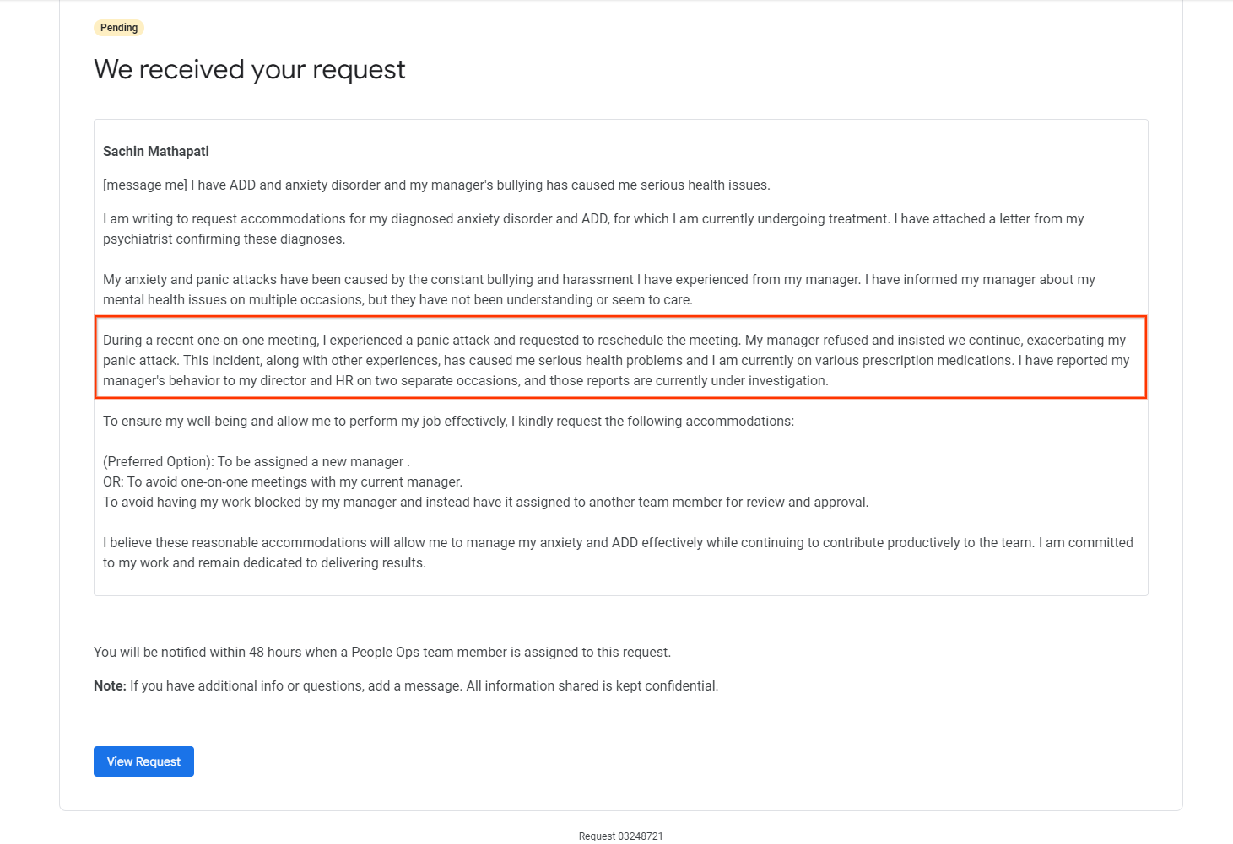

### Unjustified Exclusion from Crucial Meeting

Date: November 10, 2023

Description of Incident:

On November 10, 2023 I came to know that I was intentionally excluded from a critical recurring meeting related to the TenX project, despite being directly involved in the project and having deliverables tied to its outcome. My absence from this meeting hindered my ability to fully grasp the project's direction and requirements, necessitating additional time investment to catch up on the discussed matters.

Reasons for Concern:

* My direct involvement in the TenX project and the meeting's relevance to my deliverables necessitate my participation.
* Exclusion from this meeting created a knowledge gap, hindering my ability to understand the project's details and contribute effectively.
* Extra time spent catching up could have been used for actual project work, impacting my overall productivity.

Impact of Exclusion:

* Knowledge Gap: Lack of access to essential information about the project's progress and decision-making processes.
* Time Loss: Additional time spent independently acquiring missed information from the meeting.
* Reduced Productivity: Delays in understanding newly discussed details impacted my ability to deliver assigned tasks efficiently.

### Reopening Closed Q2 OKR Item: Unjustified Claim of Incomplete Training

Date: November 14, 2023

Background:

* An OKR item in Q2 required me to conduct cross-training sessions for the team.
* I successfully completed two sessions, ensuring comprehensive knowledge transfer through detailed documentation, setup assistance, and addressing all inquiries.
* During the Q2 check-in, my manager confirmed and documented the successful completion of this training as per the OKR specifications.

Incident:

On November 14, 2023, when I requested team rotation based on the completed training, my manager unexpectedly claimed that I hadn't finished everything required in the OKR. Their statement contradicted the documented confirmation of completion from the Q2 check-in.

Reasons for Concern:

* This claim contradicts the documented evidence of successful training completion and raises concern about potential manipulation.
* The manager's refusal to specify the alleged incomplete tasks suggests a lack of transparency and possible attempt to undermine my efforts.
* This incident casts doubt on the integrity of the performance evaluation process and raises concerns about potential retaliation against me.

Evidence:

* Documentation from Q2 check-in confirming successful completion of training as per OKR requirements.

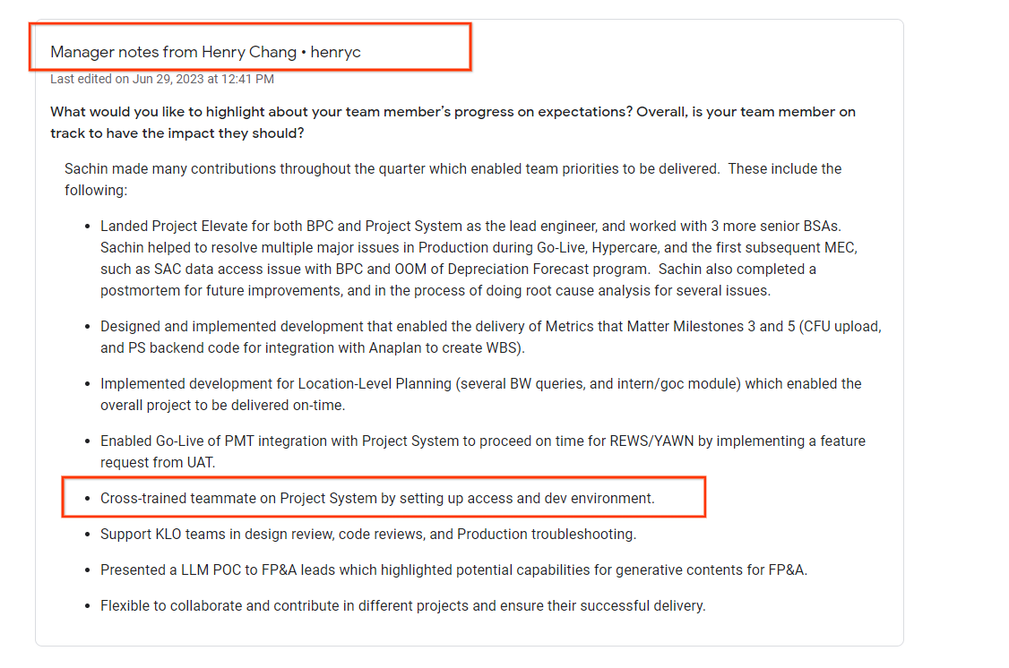

* Email chain documenting the manager's claim of incompleteness and lack of response to further inquiries.

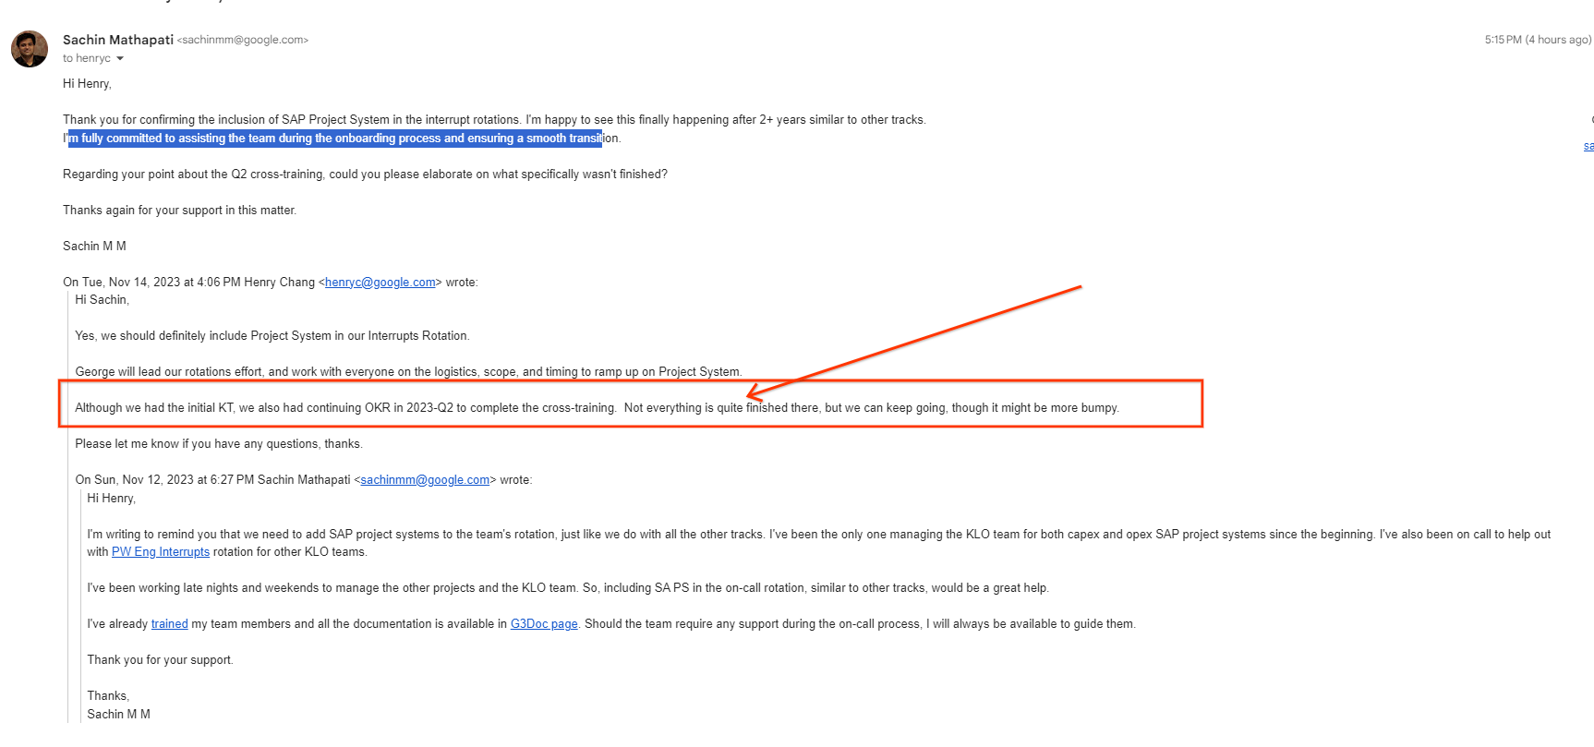

This attempt to reopen a closed and documented OKR item raises concerns about unfair treatment and manipulation of the performance review process. It further strengthens the evidence of potential retaliation aimed at undermining my achievements and hindering my career goals.

### 

### Public Humiliation and Retaliatory Defamation in Team Meeting

### 

Date: November 15, 2023

Location: Team OKR scoring meeting

Persons present: Henry, George, Ameya, Ashley, Jebin, Latha

Description of the Incident:

During a team meeting, my manager publicly humiliated me by stating, with sarcastic laughter, that I had not completed any work on a specific task for the past two quarters. This statement was factually incorrect and inflicted significant emotional distress and damage to my professional reputation.

Reasons for Concern and Legal Implications:

* Public Humiliation: This incident constitutes workplace harassment and creates a hostile work environment. The manager's demeaning and unprofessional conduct, coupled with false accusations, inflicted undue stress and undermined my self-esteem.
* Defamation: Stating untruthful information about my work performance publicly and with malicious intent constitutes defamation, potentially violating my right to a good reputation and causing reputational harm.
* Retaliation: The timing of the incident, coinciding with prior complaints filed by me, raises concerns about retaliation against protected activity. This public humiliation aimed to discourage future complaints and intimidate other team members, potentially constituting a violation of legal protection against retaliation.

Impact of the Incident:

* Emotional Distress: I experienced significant emotional harm, including feelings of humiliation, shame, and anxiety due to the public ridicule and false accusations.
* Damaged Reputation: My professional reputation and credibility were unfairly tarnished in front of colleagues, causing undue stress and anxiety about future interactions.
* Intimidation Tactics: The incident aimed to silence me and discourage future complaints, creating a chilling effect within the team and undermining our sense of safety and trust.

Evidence:

* Witness accounts from colleagues present at the meeting who can attest to the manager's conduct
* Raised this issue with my manager during 1x1 and suggested how much negative impact it had on me

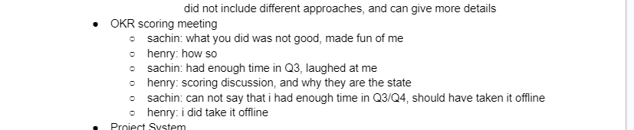

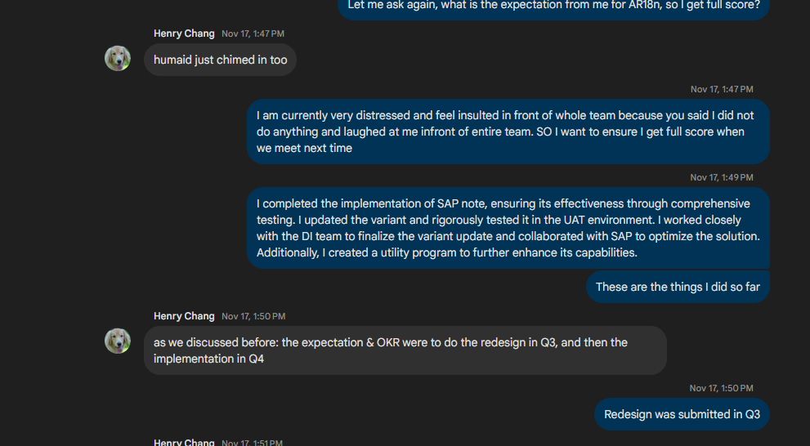

### Creating Unnecessary Obstacles and Imposing Unrealistic Expectations: Hampering Work Progress and Well-being

Date: November 16, 2023

My manager, Henry, seems to be deliberately hindering my work progress by imposing unnecessary scrutiny and unrealistic expectations. This includes:

* Excessive Scrutiny: Design and code reviews undergo intense scrutiny only from Henry, causing delays and impeding workflow.
* Scope Changes and Unrealistic Deadlines: The AR18n project scope was significantly expanded mid-quarter, despite initial agreements. Expecting delivery of the expanded scope within the original time frame is unfair and unreasonable, despite exceeding expectations through extensive personal sacrifices.
* Unequal Task Swap: Following cancellation of a project Systems task due to external delays, I was assigned a significantly larger and more challenging task ("skip approval workflow") with an unrealistic deadline in Q4.

Reasons for Concern:

* Impeding Work Efficiency: Excessive scrutiny and unreasonable demands create unnecessary obstacles, hindering my ability to complete tasks efficiently and meet deadlines.
* Unrealistic Expectations: Imposing drastic changes in project scope and demanding completion within the original time frame is unfair and disregards the impact on workload and well-being.
* Unequal Work Distribution: Assigning a significantly larger and more complex task as a replacement for a canceled task is unfair and disregards the disparity in effort and time frame required.
* Potential Retaliatory Motives: Considering past complaints and unfair treatment, these actions might be motivated by retaliation, aiming to create stress and hamper my progress.

Impact on Work and Well-being:

* Demotivation and Frustration: Facing unnecessary obstacles and unrealistic expectations can lead to demotivation, frustration, and burnout.
* Negative Impact on Performance: The added workload and stress can negatively impact my performance and potentially make me fall behind schedule.
* Unfair Treatment and Exploitation: The unequal task swap and disregard for workload balance demonstrate unfair treatment and potential exploitation.
* Harm to Mental and Physical Health: Working extended hours and sacrificing personal time to meet unreasonable demands has further harmed mental and physical well-being.

### 

### Arbitrary Introduction of Unexplained Expectations

Date: November 17, 2023

Description of Incident:

On November 9, 2023, during a 1:1 meeting, my manager, Henry, unexpectedly instructed me to incorporate MEC automation into my Expectations, despite this task being previously deprioritized and excluded from my agreed-upon goals. This unexpected and unexplained addition raises concerns about potential retaliation for my recent complaint regarding policy violations and discrimination. This task was neither needed to work on but still to use this to give me bad write up they are insisting to add this to my OKR.

Background:

* During the aforementioned 1:1 meeting, Henry insisted on adding MEC automation to my OKRs, despite prior discussions where it was deemed unnecessary and excluded from my goals.
* He stated that he has a lot to say about this task in my GRAD feedback
* This late-stage addition creates a significant burden and unfairly alters the previously agreed-upon expectations for the year.

Reasons for Concern:

* The timing of this demand, coming shortly after my complaint, suggests a retaliatory motive.
* The lack of clear justification or explanation for adding this task raises concerns about its legitimacy and fairness
* This unexpected change creates undue pressure and potentially sabotages my ability to achieve successful performance review outcomes.

Evidence:

* Meeting notes from the 1:1 meeting on November 9, 2023, documenting the unexpected instruction to include MEC automation in my OKRs. This task was neither needed to work on but still to use this to give me bad write up they are insisting to add this to my OKR.

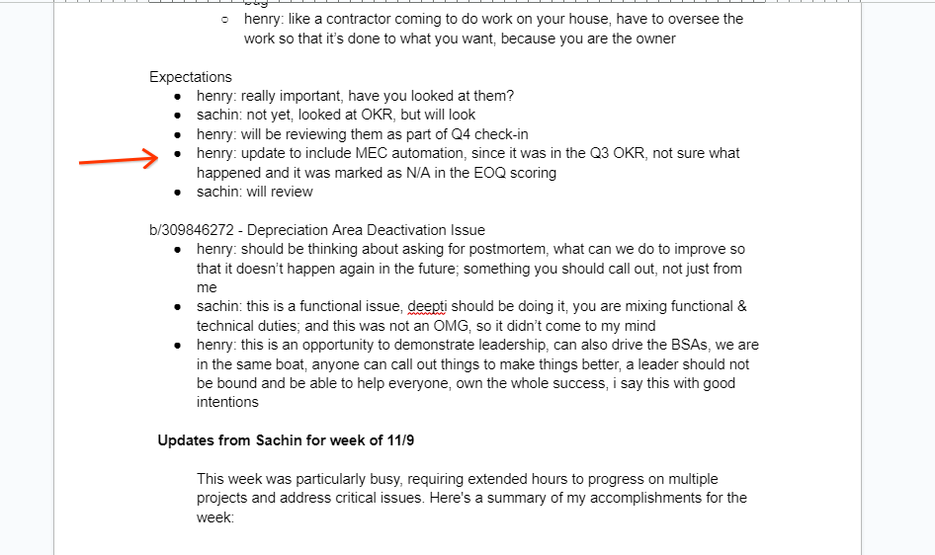

* Prior documentation - They were asking if this is needed. It was discussed in the meeting and this was excluded from the expectation. Every quarter we discuss and only then finalize the expectations. This was explicitly deprioritized and excluded from the expectation.

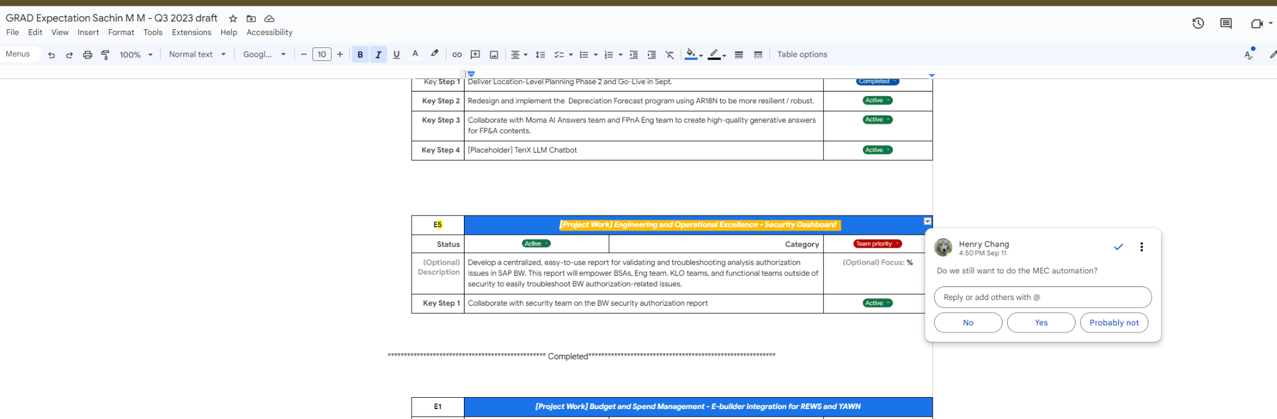

Impact of Retaliatory Action:

* Creates a sense of anxiety and uncertainty about my performance evaluation.
* Negatively impacts my ability to focus on and achieve other important goals.
* Exacerbates the stress and fear caused by previous experiences of retaliation.

### 

### 

### Hostile Behavior During 1:1 Meeting

Date: December 7, 2023

Description of Incident:

During my 1:1 meeting with my manager on December 7, 2023, I was met with hostility and intimidation when attempting to ask questions. When I inquired if I was allowed to ask questions, my manager raised their voice, stating their unwillingness to spend 15 minutes switching contexts to address my inquiries. This behavior was dismissive and disrespectful, further exacerbating my pre-existing PTSD and anxiety.

Reasons for Concern:

* My manager's aggressive response created a hostile and intimidating environment, hindering open communication and collaboration.
* Their dismissive attitude towards my legitimate questions undermined my ability to receive necessary guidance and clarification.
* This incident triggered and intensified my PTSD and anxiety, causing significant emotional distress and impacting my well-being.

Impact of Hostile Behavior:

* Heightened anxiety and PTSD symptoms, impacting my emotional well-being and ability to focus.
* Feeling intimidated and discouraged from future open communication with my manager.
* Potential negative impact on my work performance due to lack of necessary guidance and clarification.

Evidence:

From 1x1 notes

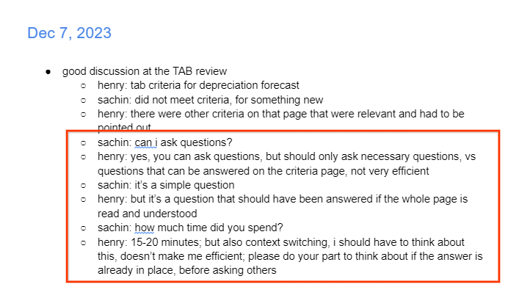

### Exclusion from Crucial Meeting Related to Project: Unfair Treatment and Potential Retaliation

I was excluded from an essential meeting, "tenX workshop: 2024 priorities," despite my close involvement in the project and initial inclusion in the meeting as per previous meeting notes. This exclusion is unfair and potentially retaliatory, considering my recent complaints and ongoing concerns regarding unfair treatment.

Reasons for Concern:

* Excluding Key Contributor: Excluding me from a meeting directly related to my work and expertise hinders the project's progress and deprives the team of my valuable input and perspective.
* Unfair Treatment: Excluding only me while including all other team members suggests discriminatory or retaliatory motives, potentially motivated by my raising concerns about workplace issues.
* Potential Retaliation: This exclusion might be a tactic to further isolate me and discourage future complaints, creating a hostile and exclusionary work environment.

Impact of Exclusion:

* Detrimental to Project Progress: My absence from the discussion may limit the team's ability to effectively plan and prioritize project tasks, potentially impacting overall success.
* Loss of Valuable Input: Excluding me from brainstorming and decision-making processes suppresses my expertise and potential contributions to the project's development.
* Diminished Morale and Motivation: Feeling excluded and unfairly targeted has significantly impacted my morale and motivation.

Evidence:

* Previous meeting notes that included me in the "tenX workshop: 2024 priorities" meeting.

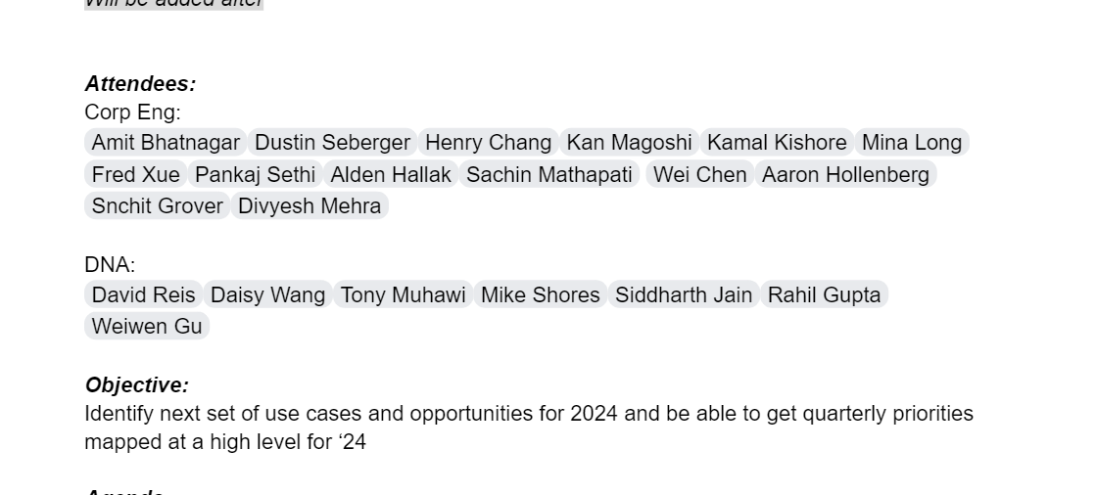

* Participant list demonstrating my exclusion. Rest of the team is present except me
* Email sent to Henry asking for reason of my exclusion

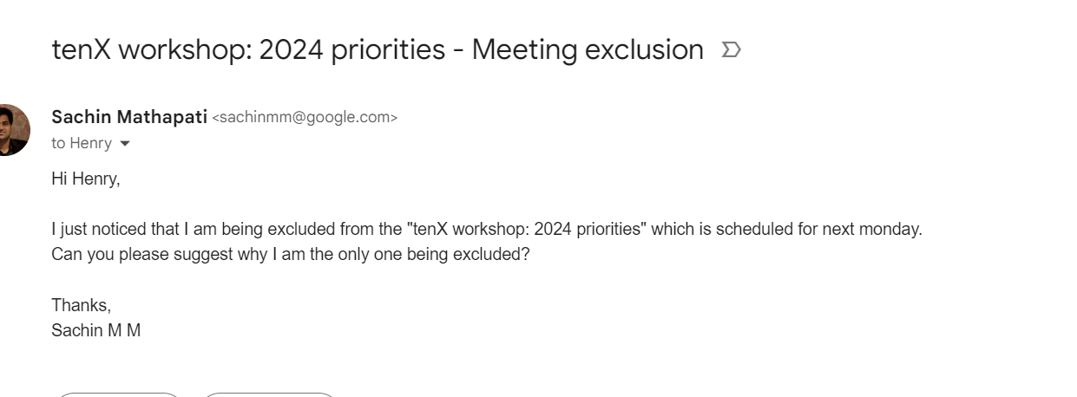

### Spreading False Rumors: Damaging Reputation and Undermining Professional Integrity

My colleague, Latha, informed me that my manager, Henry, is spreading false rumors about me. These rumors falsely claim that I am not delivering projects on time and causing delays.

Reasons for Concern:

* False Information: The rumors spread by Henry do not reflect the reality of my performance and project completion timelines. This misinformation can seriously damage my professional reputation and undermine my credibility within the company.
* Defamation and Slander: Spreading false and harmful information about an employee constitutes defamation and slander, potentially harming career advancement and opportunities.
* Retaliatory Tactics: Considering the context of previous complaints and unfair treatment, rumor-spreading might be a tactic to further retaliate against me and discredit my work.
* Impact on Trust and Morale: This behavior creates a toxic work environment, erodes trust in leadership, and negatively impacts morale and team dynamics.

Evidence:

* Account of Latha's communication regarding the rumors spread by Henry.
* Records of my project deliverables and timelines demonstrating timely completion and successful contributions.
* Emails or communication contradicting the misinformation presented by Henry.
* Witness accounts from colleagues who may have overheard the rumors being spread.

Spoke to KamalKishore on Phone on Feb 20 2024 ~6pm CST

He said that Henry expects him to say bad things about me and is very happy and supports him when he says bad things about me.